**Practical No.:-4**

**a**):- Create a Registration form to demonstrate use of various Validation controls.

**Program:-**

**🡪Default.aspx.cs:**

using System;

using System.Collections.Generic;

using System.Linq;

using System.Web;

using System.Web.UI;

using System.Web.UI.WebControls;

public partial class _Default : System.Web.UI.Page

{

protected void Page_Load(object sender, EventArgs e)

{}

protected void CustomValidator1_ServerValidate(object source, ServerValidateEventArgs args)

{

if ((args.Value).Length < 8)

{

args.IsValid=false;

}

else

{

args.IsValid = true;

l1.Text = "Welcome " + t1.Text;

}

}

}

**🡪Default.aspx:**

<%@ Page Language="C#" AutoEventWireup="true" CodeFile="Default.aspx.cs"

Inherits="_Default" %>

<!DOCTYPE html>

<html xmlns="http://www.w3.org/1999/xhtml">

<head runat="server"></head>

<body>

<form id="form1" runat="server">

<div>

Name:<asp:TextBox ID="t1" runat="server"></asp:TextBox>

<asp:RequiredFieldValidator ID="RequiredFieldValidator1" runat="server"

ControlToValidate="t1" ErrorMessage="Enter Name"> *

</asp:RequiredFieldValidator><br />

Age: <asp:TextBox ID="t2" runat="server"></asp:TextBox>

<asp:RequiredFieldValidator ID="RequiredFieldValidator2" runat="server"

ControlToValidate="t2" ErrorMessage="Enter Age">*</asp:RequiredFieldValidator>

<asp:RangeValidator ID="RangeValidator1" runat="server" ControlToValidate="t2"

ErrorMessage="Age Out of Range" MaximumValue="99"

MinimumValue="15">*</asp:RangeValidator><br />

Email: <asp:TextBox ID="t3" runat="server"></asp:TextBox>

<asp:RegularExpressionValidator ID="RegularExpressionValidator1"

runat="server" ControlToValidate="t3" ErrorMessage="Enter correct Email"

ValidationExpression="\w+([-+.']\w+)*@\w+([-.]\w+)*\.\w+([-

.]\w+)*">*</asp:RegularExpressionValidator><br />

Password : <asp:TextBox ID="t4" runat="server" TextMode="Password"

CausesValidation="True"></asp:TextBox>

<asp:CustomValidator ID="CustomValidator1" runat="server"

ControlToValidate="t4" ErrorMessage="Password too Short"

OnServerValidate="CustomValidator1_ServerValidate"

ValidateEmptyText="True">*</asp:CustomValidator><br />

Confirm Password : <asp:TextBox ID="t5" runat="server"

TextMode="Password"></asp:TextBox>

<asp:CompareValidator ID="CompareValidator1" runat="server"

ControlToCompare="t4" ControlToValidate="t5" ErrorMessage="Password Didn't

Match">*</asp:CompareValidator><br /><br />

<asp:Button ID="Button1" runat="server" Text="Submit" /><br />

<asp:ValidationSummary ID="ValidationSummary1" runat="server" /><br /><br />

<asp:Label ID="l1" runat="server"></asp:Label>

</div></form></body></html>

**Output:-**

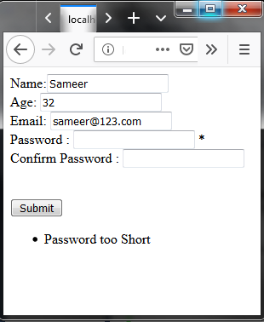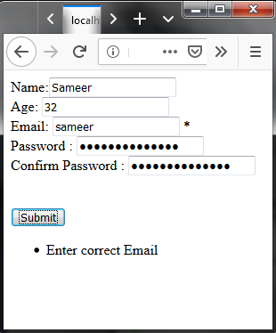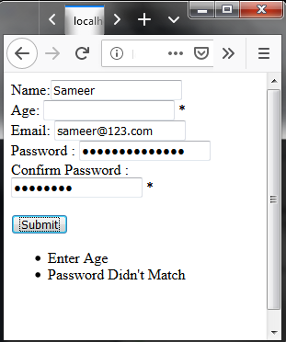

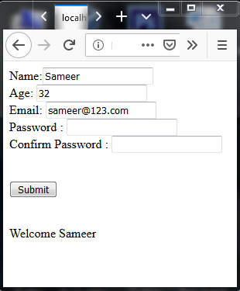

**Practical No.:-4**

**b**):- Create Web Form to demonstrate use of Adrotator Control.

**Program:-**

Add a XML file, name it "ad.xml"



Add images to test out the adrotator functionality.

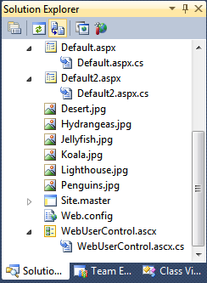

**XML File**

<Advertisements>

<Ad>

<ImageUrl>Desert.jpg</ImageUrl>

<NavigateUrl>**http://www.desertsafaridubai.com**</NavigateUrl>

<AlternateText>

Enjoy the desert safari!!!

</AlternateText>

<Impressions>20</Impressions>

<Keyword>desert</Keyword>

</Ad>

</Advertisements>

**Default.aspx**

<asp:AdRotator ID="AdRotator1" runat="server" DataSourceID="XmlDataSource1" />

<asp:XmlDataSource ID="XmlDataSource1" runat="server"

DataFile="~/ADFILE.xml"></asp:XmlDataSource>

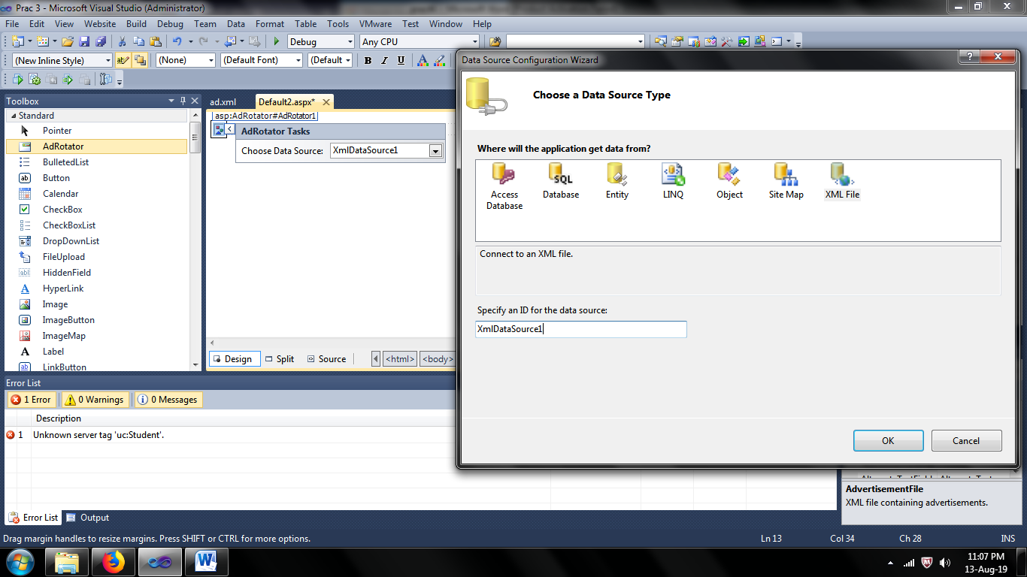

**Output:-**

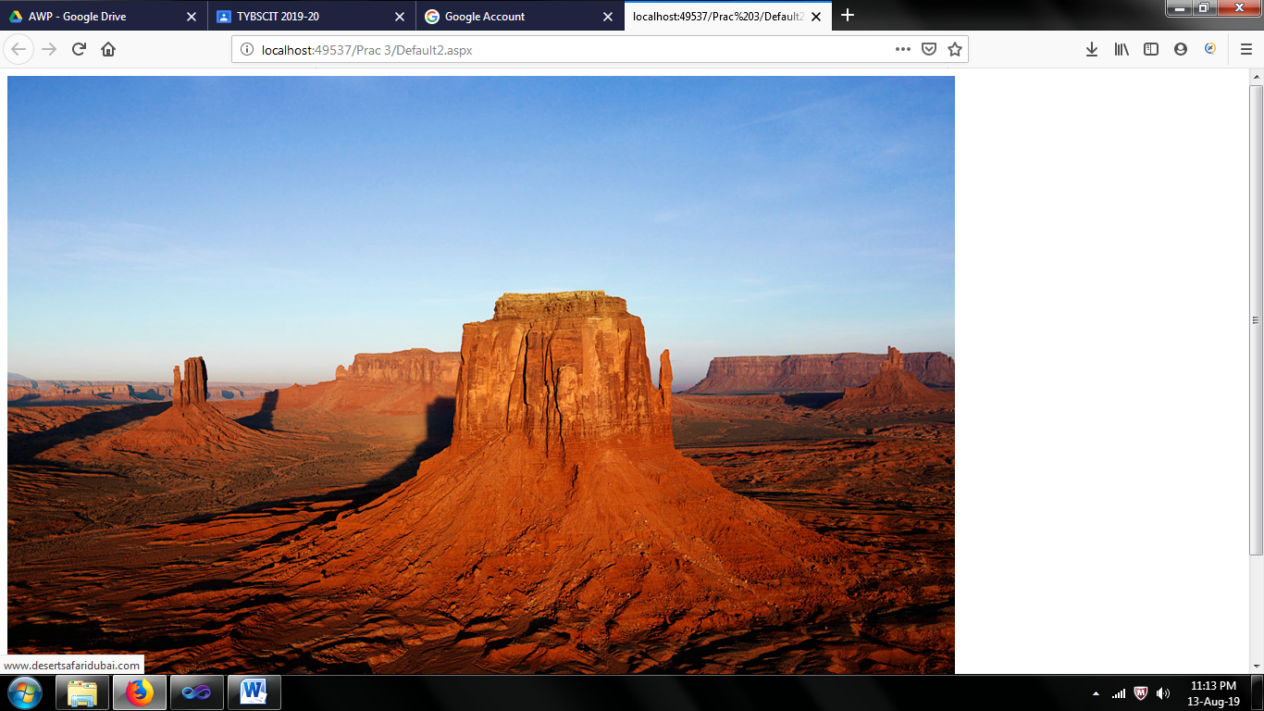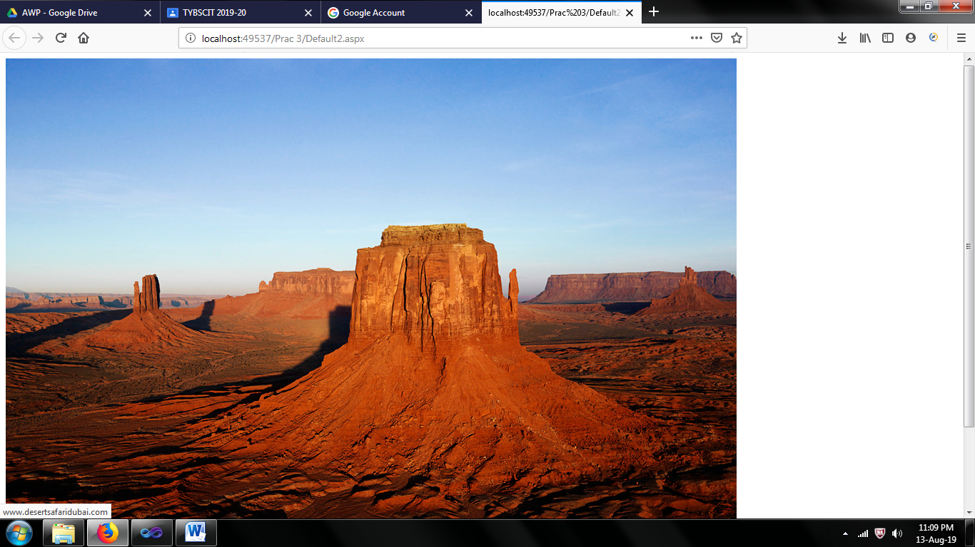

**Practical No.:-4**

**c**):- Create Web Form to demonstrate use of User Controls.

**Program:-**

Add Web User Control

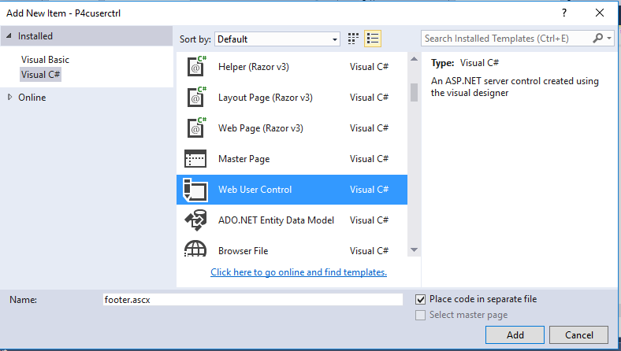

Website -> Add -> Web User Control and Name it ‘WebUserControl’.

**WebUserControl.ascx**

<%@ Control Language="C#" AutoEventWireup="true" CodeFile="WebUserControl.ascx.cs" Inherits="WebUserControl" %>

<p>Name&nbsp;&nbsp;&nbsp; :&nbsp;&nbsp;&nbsp;&nbsp;

<asp:TextBox ID="TextBox1" runat="server" Width="167px"></asp:TextBox></p>

<p>City&nbsp;&nbsp;&nbsp;&nbsp;&nbsp;&nbsp; :&nbsp;&nbsp;&nbsp;

<asp:TextBox ID="TextBox2" runat="server" Width="173px"></asp:TextBox></p>

<p> <asp:Button ID="Button1" runat="server" onclick="Button1_Click" Text="Submit" /></p>

<p><asp:Label ID="Label1" runat="server"></asp:Label></p>

**WebUserControl.ascx.cs**

protected void Button1_Click(object sender, EventArgs e)

{

Label1.Text = "Your Name is " + TextBox1.Text + " and you are from " + TextBox2.Text;

}

**Default.aspx**

<%@ Page Language="C#" AutoEventWireup="true" CodeFile="Default2.aspx.cs" Inherits="Default2" %>

<!DOCTYPE html PUBLIC "-//W3C//DTD XHTML 1.0 Transitional//EN" "http://www.w3.org/TR/xhtml1/DTD/xhtml1-transitional.dtd">

<%@ Register Src="~/WebUserControl.ascx" TagPrefix="uc" TagName="Student"%>

<!DOCTYPE html>

<html xmlns="http://www.w3.org/1999/xhtml">

<head id="Head1" runat="server">

<title></title>

</head>

<body>

<form id="form1" runat="server">

<div>

<uc:Student ID="studentcontrol" runat="server" />

</div>

</form>

</body>

</html>

**Output :**

